Project Proposal

By Zixi Chen

Project description

* Three Kingdom Warrior Game
* The game is based on the Chinese historical period of three kingdoms. The game is similar to a chessboard game in which the users can control different types of warrior figures – infantry, cavalry, archers and sorcerers – to combat with other player or a computer AI. Each type of warrior figure has different attack abilities or spell abilities. The goal of the game is to eliminate all the warriors of the other player.

Structural plan (ordered in files and classes)

* Character file
  + Mycharacter class
  + Enemy class
* Layout file
  + Grid class
  + Attackrange class
  + Spell class
* Features file
  + TerrainSpell class – matching terrain with spell ability. For example, forest will enhance the damage of fire spell
  + SpecialTerrian class – characters cannot move across certain terrains. For example, the city wall cannot be crossed.
* Parameters file
  + characterParameters class – recording the moving range, attack, defense and spell damage
* multiplayer file
  + using sockets to include another player
* sound file
  + background music and sound effects of attack and spell
* AI file
  + Algorithm of computer-generated moves against the user from data imported from AIstats file
* AIstats file
  + Record the user’s moves and feed the data to AI file.

Timeline plan

* 4.15.2019 – character walking animation, character movement on a gird-based platform, displaying attack range when clicking on the characters
* 4.18.2019 – creating at least two different characters and implement different attack ranges and movement ranges, brief animation of character movement.
* 4.19.2019 – terrain obstacles and spell enhancements based on terrains
* 4.22.2019 – sockets that allow multiple players
* 4.26.2019 – finish implementing AI that gives computer-generated moves
* 4.30.2019 – finishing refining graphics and adding all characters
* 5.1.2019 – testing and debugging

Module list

* Pygame and sockets

Version Control

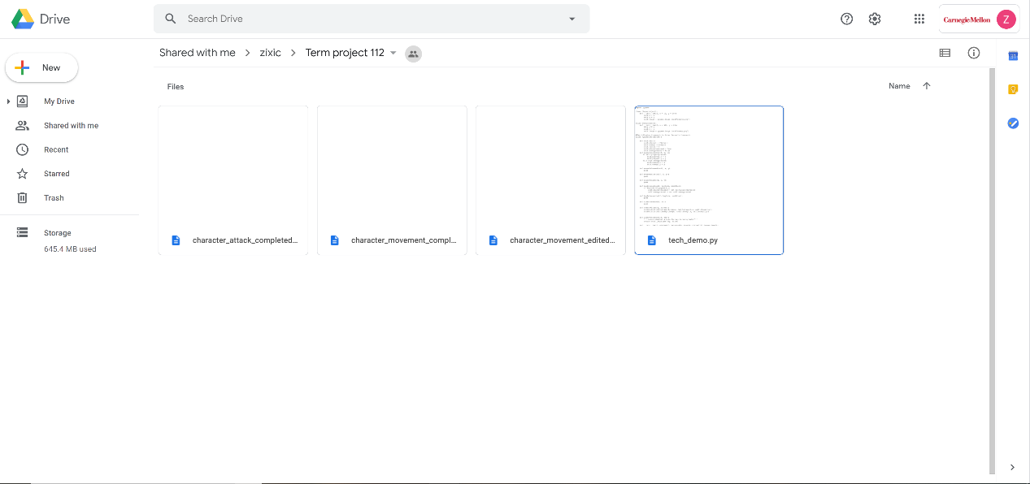

As illustrated by the image, all files will be uploaded to google drive. A new file will be uploaded when a new feature is completed such as character movement.



According to the progress of the term project, the first completed feature file will be marked as Version 1. The rest will be marked Version 2, 3, 4 based on the order that the feature files is completed. If any file needs to be edited, its version will be changed to Version X.2.

All files with the same naming rules are also backed up in a USB drive as a second backup.

TP2 update:

* Added new features to the game
  + A blue movement range appears when the user clicks on the character
  + Character’s animation stops when the character finishes attacking. The character cannot be selected anymore until the next round.
  + Got rid of character’s moving animation because when characters move, they go from one place to the next place directly. I don’t have enough time to add in any animation and it is not necessary.
  + At the bottom of each character, there is a blood box showing their health. For sorcerers, there are a blood box and a magic box.

TP3 update (No change)